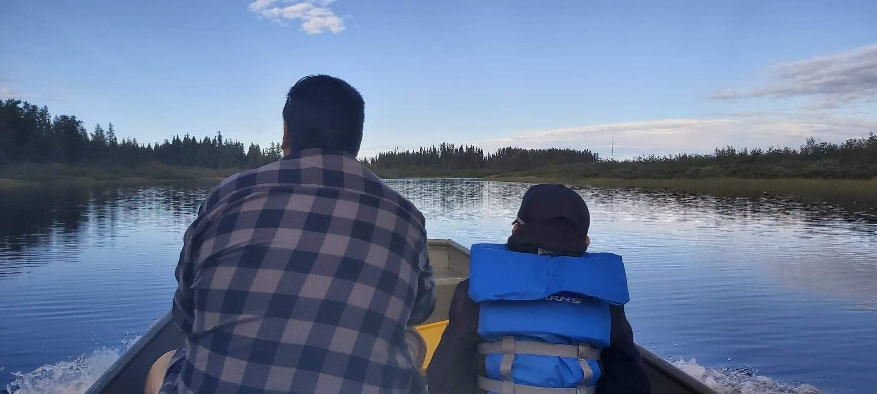  Do you have a natural resource use or conservation project in mind for your community, organization, or small business?  The Canada Ontario Resource Development Agreement (CORDA) Office is now accepting funding applications for 2022-2023.  Eligible project categories include:  - Forestry  - Trapping  - Fishing  - Harvesting (such as wild rice)  - Resource planning  - Eco-Tourism  The CORDA Office has moved  - Maple syrup production  - And more!  Projects may include training (such as a youth trapper courses), employment, stewardship, traditional learning, equipment (such as humane traps), and supplies (such as trees for planting).  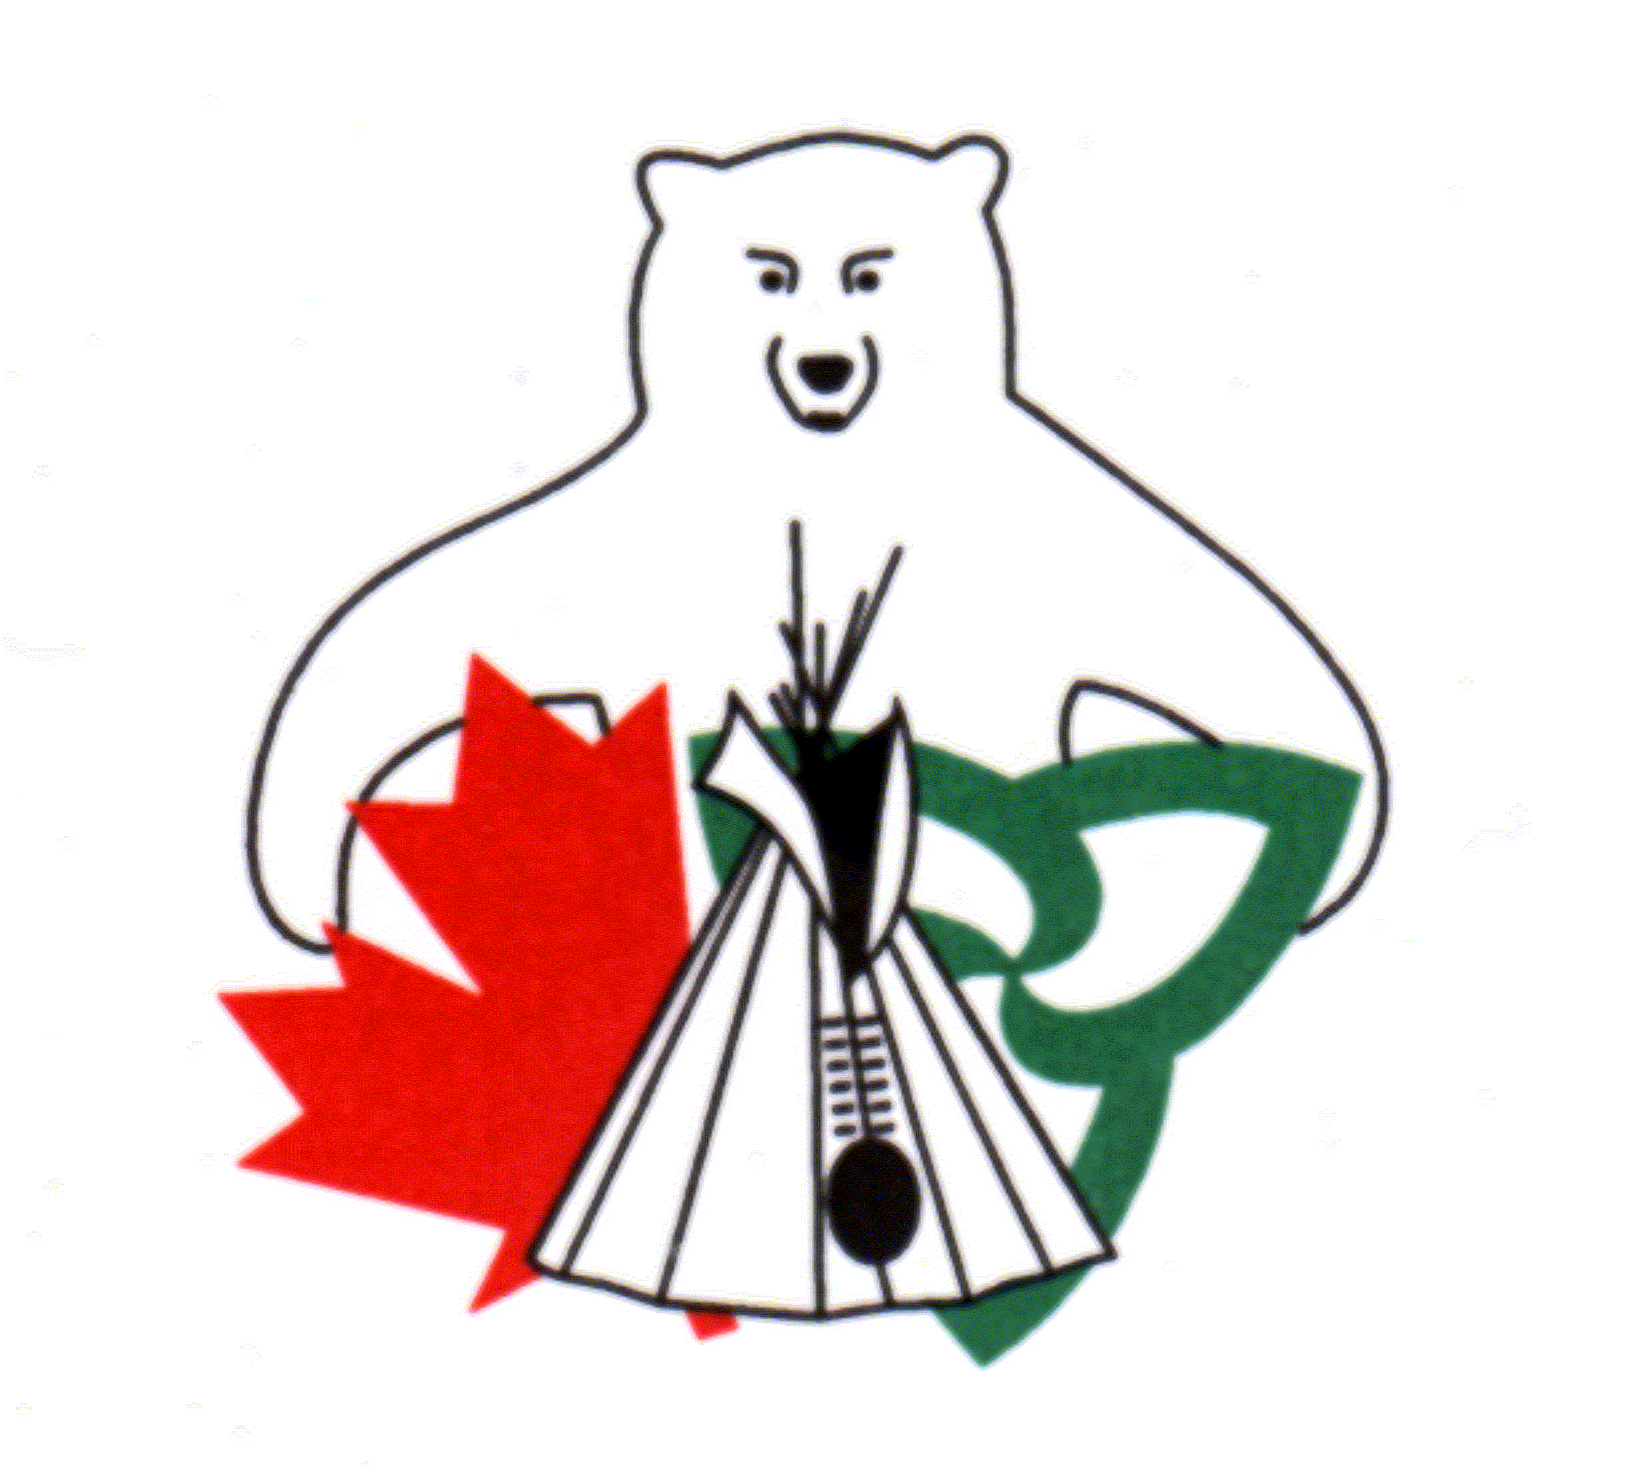  To obtain more information about project eligibility or to request an application package, please contact  Laura Howard, Secretariat, CORDA Office  or visit:  http://www.hiawathafirstnation.com/services-departments/corda/ | The Canada Ontario Resource Development Agreement (CORDA) is an agreement between Canada, Ontario and First Nations’ members in Ontario.  ────  The Agreement promotes resource and economic development opportunities.  ────  First Nations, their members and organizations, and Territorial Organizations in Ontario are eligible to apply for funding.  ────  The maximum funding level per project is $35,000.00  ────  Project approval is subject to funding availability.  CORDA Office  431 Hiawatha Line  Hiawatha, ON K9J 0E6  Tel: 705-295-4421  Fax: 705-996-4501  corda@hiawathafn.ca
Applications are due to the CORDA Office by 11:59 p.m. EST Monday, October 4, 2021.

